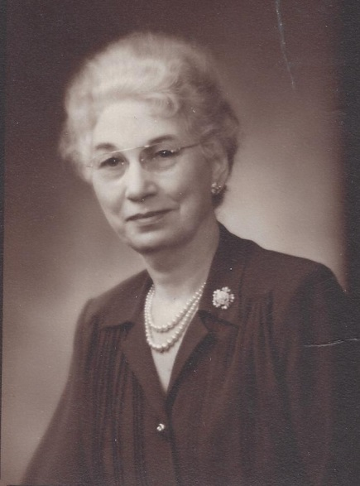

Anne Foster Stickney, Mary Helen Foster Wolfe’s

half-sister - abt 1935 (est.)

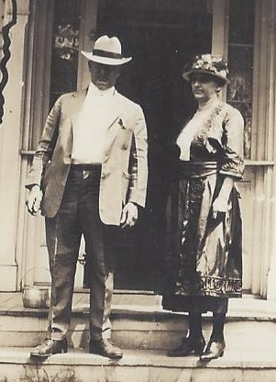

Floyd & Minnie Foster Hickle, Mary Helen Foster

Wolfe’s mother and step-father - Aug 1921